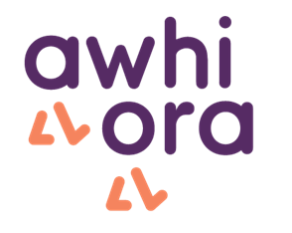
Walk Alongside Support

It can be tricky to navigate which road to take sometimes, and that’s where we step in.
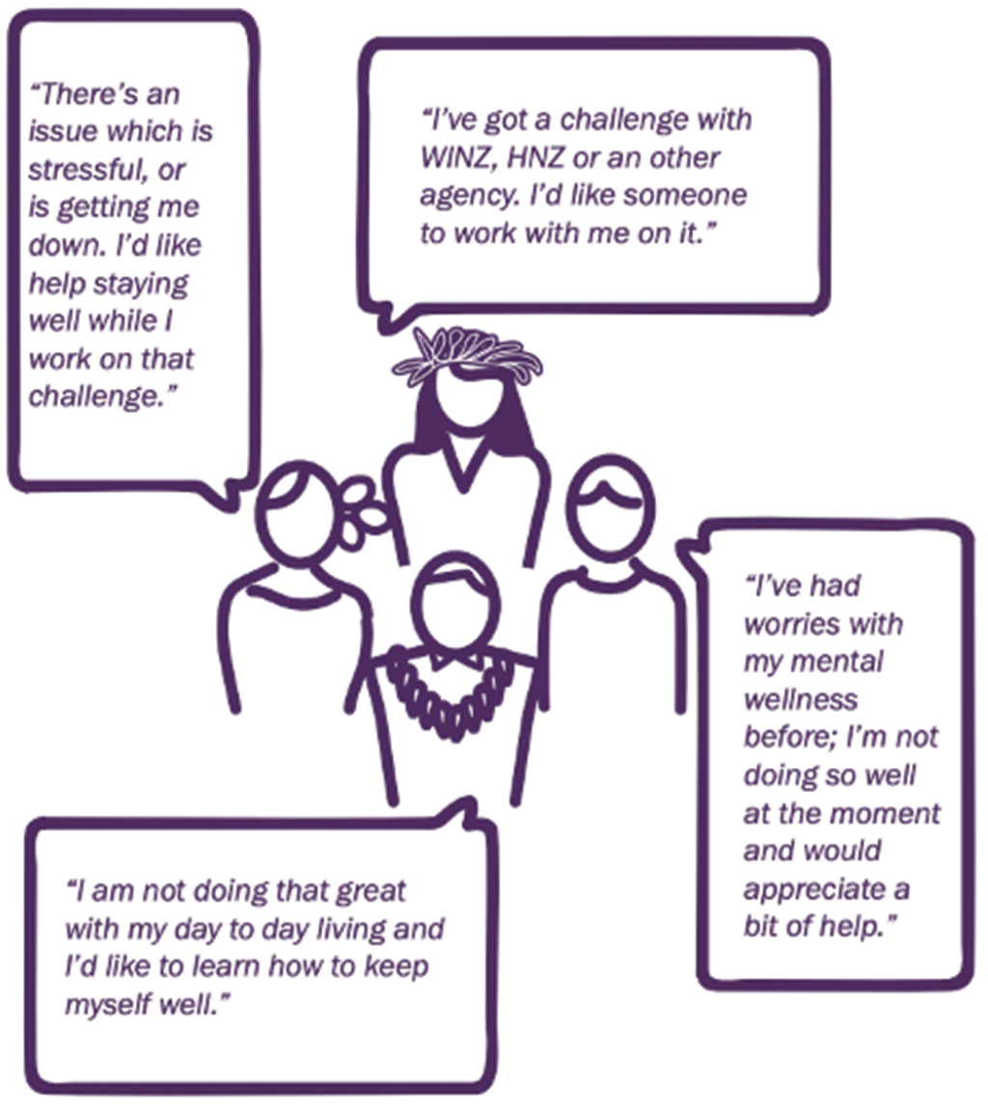

Awhi Ora consists of trained support workers/peer support workers from health and wellbeing organisations who can walk alongside you during the difficult times in your life.
NGO Name
Phone
Email

